Blockchain Full course

Modules

1. Blockchain fundementals

Replacing Transaction system

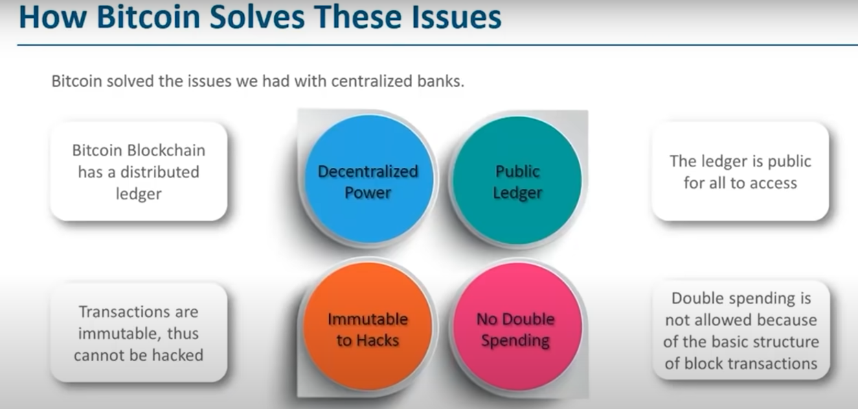

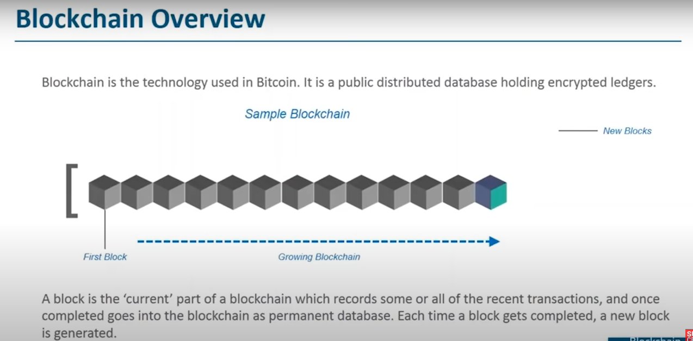

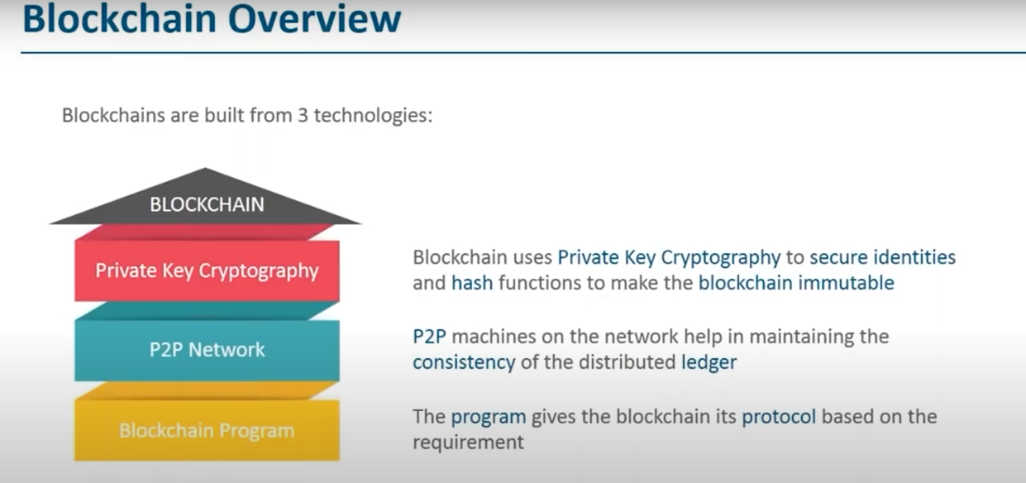

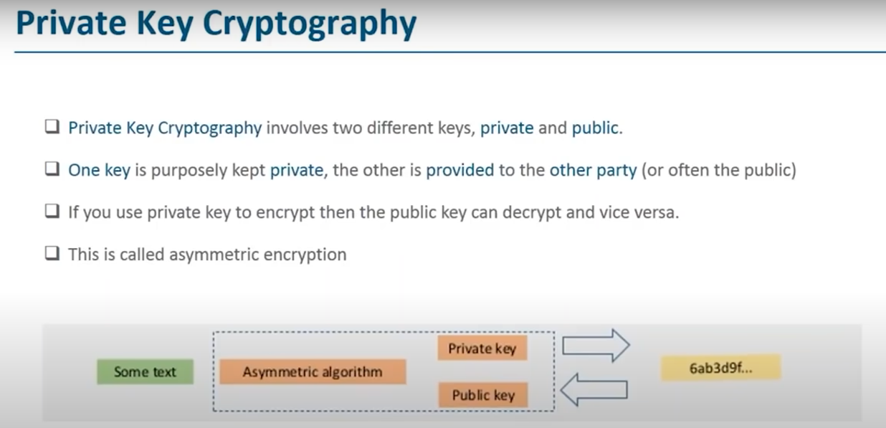

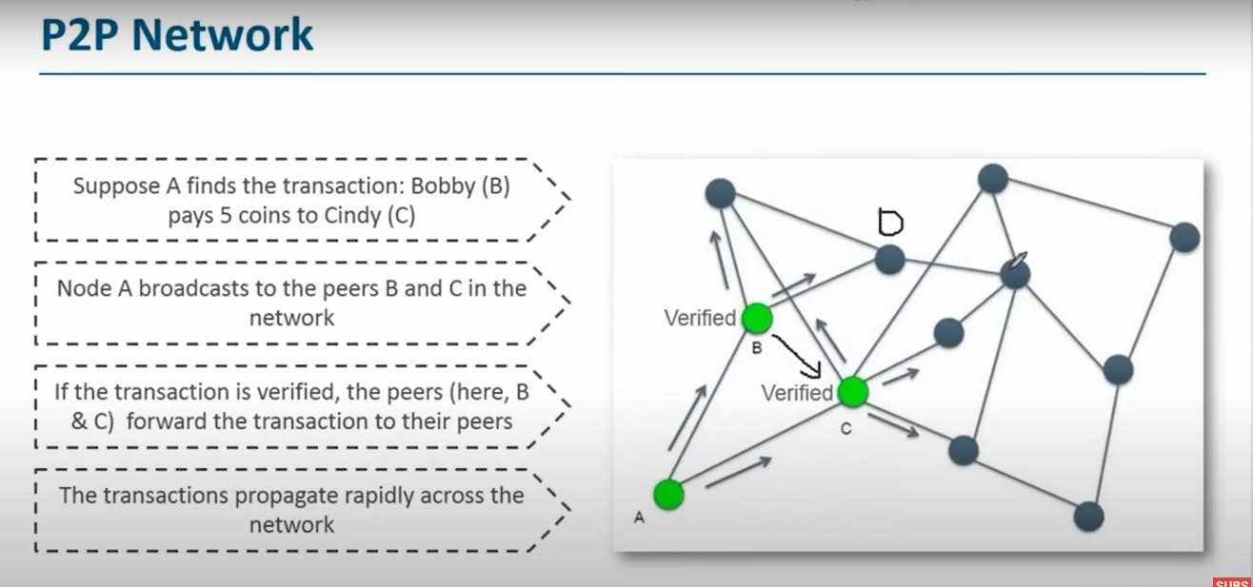

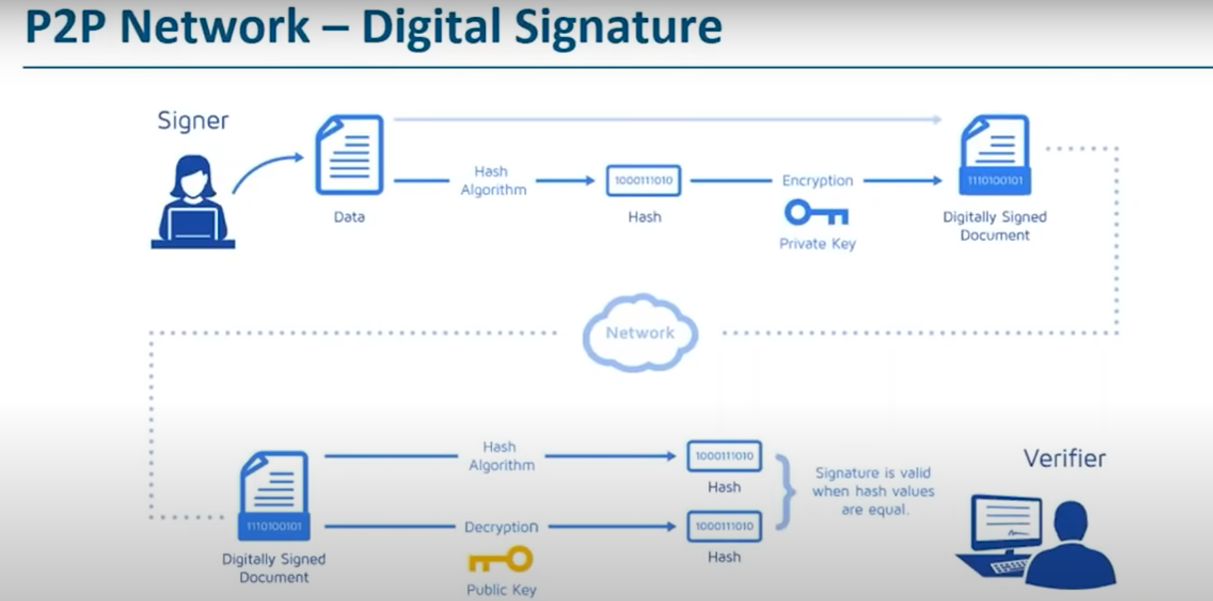

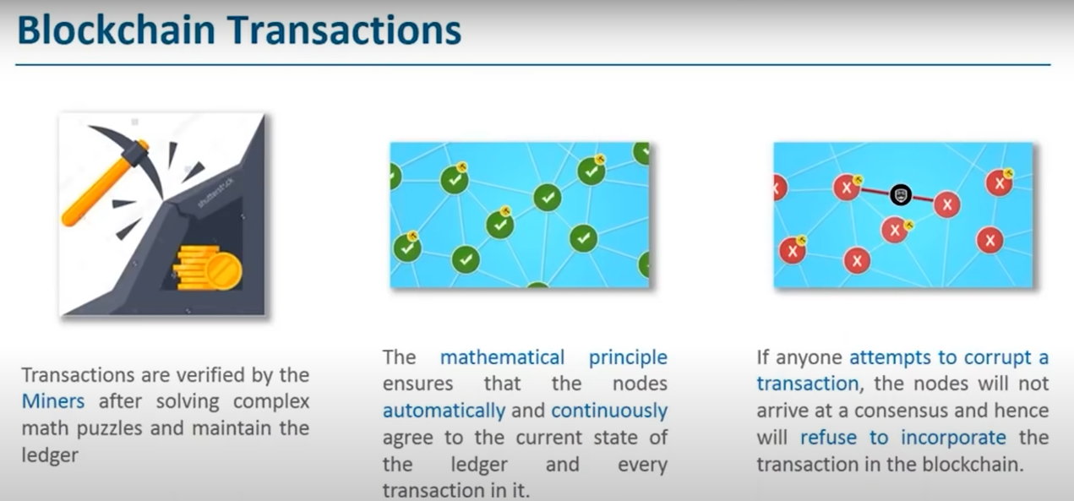

1. Blockchain Applications
2. Blockchain Wallets
3. Ethereum Fundementals
4. Ethereum vs Bitcoin
5. Ethereum Development Tools
6. Smart contracts
7. Ethereum Dapp
8. Hyperledger
9. Hashgraph
10. Blockchanin interview